OPERATING SYSTEMS LAB EXPERIMENTS
Name:- G. Lakshmi Keertana
Roll.no:- 2420090075
Sec:-06

1. Aim
To study file I/O performance and understand how buffering in C affects data integrity by implementing a 'write temporary file then rename' update protocol.

2. Problem Statement
When programs write data directly to a file, a crash or power failure during the write operation can leave the file partially written or corrupted. Students implement a safe update protocol where data is first written to a temporary file and then renamed to the original file after the write is completed. They simulate crashes during different stages and check file integrity after restart.

3. Procedure
Open a Linux terminal or C programming environment.
Create a file named file_update.c.
Write the C program implementing the temporary write protocol.
Compile the program using GCC.
Run the program and observe file update behavior.

4. C Program
#include <stdio.h>
#include <stdlib.h>
int main() {
FILE *temp;
char data[] = "This is updated data written safely.\n";
temp = fopen("temp.txt", "w");
if (temp == NULL) {
printf("Error opening temporary file\n");
return 1;
}
fprintf(temp, "%s", data);
fclose(temp);
remove("data.txt");
rename("temp.txt", "data.txt");
printf("File updated safely using temp file method\n");
return 0;
}

5. Output
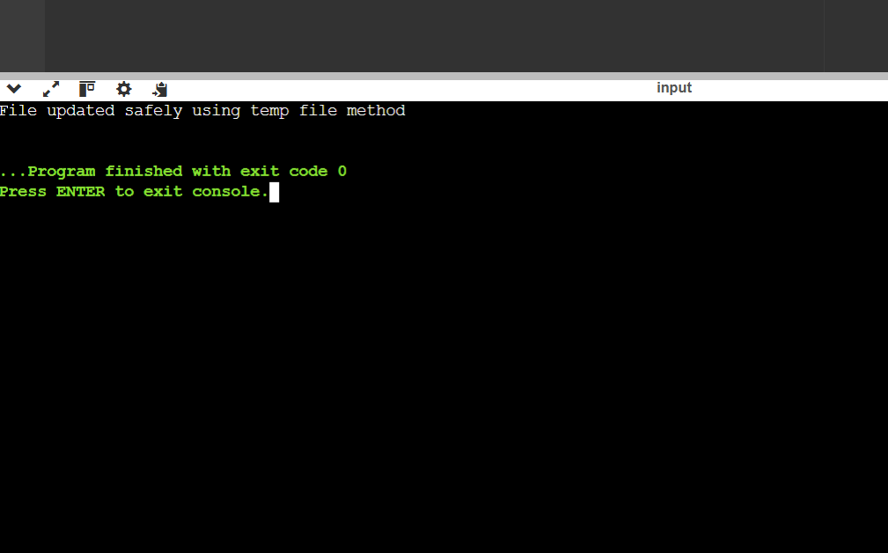

1. Aim
To study Inter Process Communication (IPC) by implementing a three-stage pipeline using pipes and observing bounded buffering and backpressure behavior.

2. Problem Statement
Processes in operating systems often communicate through pipelines such as collector → parser → writer. If the writer process becomes slow, data can build up in the pipeline. This experiment demonstrates backpressure where upstream processes slow down due to limited buffering.

3. Procedure
Open a Linux terminal.
Create a file named pipeline.c.
Write a C program implementing pipeline communication using pipes.
Compile the program using GCC.
Run the program and observe data flow between processes.

4. C Program
#include <stdio.h>
#include <unistd.h>
#include <string.h>
int main() {
int pipefd[2];
pipe(pipefd);
if(fork()==0) {
close(pipefd[1]);
char buffer[100];
while(read(pipefd[0], buffer, sizeof(buffer)) > 0) {
printf("Writer received: %s", buffer);
sleep(2);
}
}
else {
close(pipefd[0]);
char *messages[] = {
"Message 1\n",
"Message 2\n",
"Message 3\n"
};
for(int i=0;i<3;i++) {
write(pipefd[1], messages[i], strlen(messages[i]));
printf("Collector sent: %s", messages[i]);
sleep(1);
}
}
return 0;
}

5. Output
